**PROJECT DEFINITION**

Tic tac toe

(Min max algorithm)

(By SEMESTER - VII 4thYear M.Sc.(2023-24))

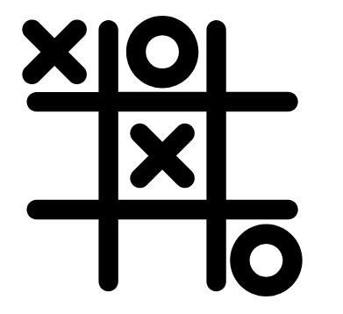

VARSHA OZA – 4043

TINKAL PRAJAPATI – 4056

SUBMITTED TO –



**INTRODUCTION**

Tic-Tac-Toe is one of the paper-and-pencil games. This game requires two players in 3x3 grid with Player 1 acts as “O” and Player 2 acts as “X”, or vice versa. The objective of this game is to take place of three connecting grids in a horizontal, vertical, or diagonal way/fork.

This game was first introduced at ancient time, however there is no evidence who invented it and which year. Some people think this game was invented at Ancient Egypt, and then Roman Empire called this game “Terni Lapilli”. The grid drawing for the game had been found chalked all over the ancient city’s ruins.

Terni Lapilli was resurfaced in England with the name “Nought and Crosses” in 1864. This resurfaced version is the modern of Tic-Tac-Toe game that people know until this present day.

In 1952, Alexander S. Douglas for the EDSAC computer at University of Cambridge developed a computerized Tic-Tac-

Toe game called “OXO”. This was the first video game of Tic- Tac-Toe and it has AI inside, therefore human could play against the computer opponent.

Tic tac toe is not very challenging game for human being. The game play is very simple two players alternately put Xs and Os in compartments of a figure formed by two vertical lines and each ties to get a row of three Xs or Os before the opponent does. when you just look at the board and instantly know where you want to move. This kind of instant knowledge is great for human beings, because it makes you a fast player. But it isn’t much help in writing a computer program. For that, you have to know very explicitly what your strategy is. In order to create a AI to play with a user. I have used Alpha Beta Pruning to achieve the goal state. Moreover, a minmax algorithm is also used. The minmax algorithm is like brute-force approach. It tries to see every possible outcome and then tries to optimize whatever options it has in hand.

**GAME STRATEGY**

Tic-Tac-Toe game has many strategies that can be used. The main point of the strategy is the players have to block the opponent fork, either horizontally, vertically, or diagonally, while the players have to find their own fork to win.

**Artificial Intelligence Implementation**

Artificial Intelligence (AI) can be used for this game in order to play only single player, in other words human against computer. There are many samples of this game with AI on the internet, and each sample has its own algorithm for AI and it depends on the developer, which kind of algorithm will be used. One of AI algorithms that can be used for Tic-Tac-Toe is Minimax algorithm. This algorithm is a reliable algorithm for Tic-Tac-Toe game. By using this strategy, computer will avoid the loser condition against human.

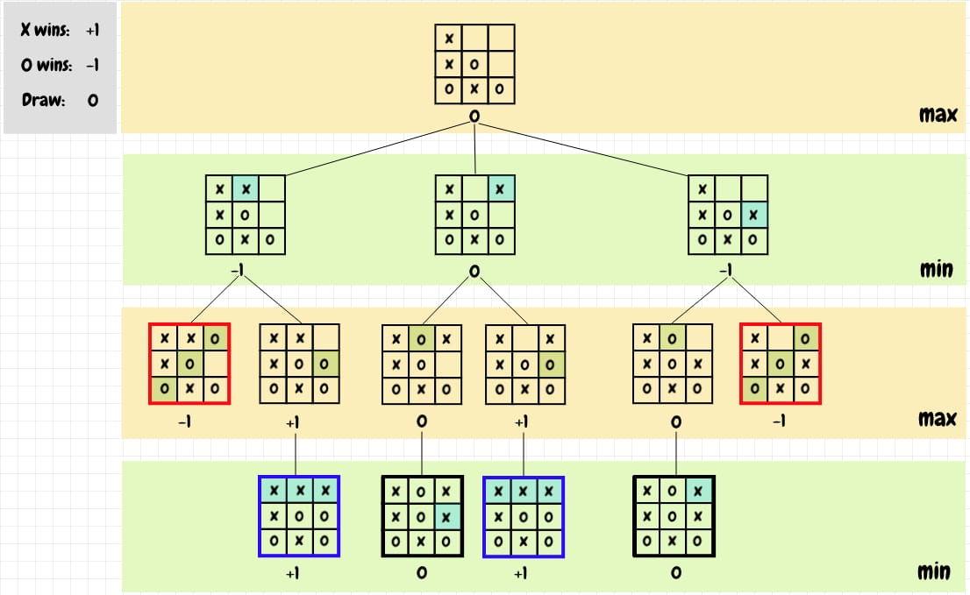

**Summary**

Tic-Tac-Toe game is a traditional game that still being played until present day. All algorithm that used in this game have the same purpose, to block the opponent’s way. Each developer has his/her own style of algorithm. However, in order to be more effective, the basic of algorithm should include all aspects based on Newell and Simon’s 1972 Tic-Tac-Toe.